##### ` A Project report on

###### SMART ATTENDANCE SYSTEM USING DEEP LEARNING AND CNN

###### A Dissertation submitted to JNTU Hyderabad in partial fulfillment of academic requirements for the award of the degree.

**Bachelor of Technology**

**IN**

**Computer Science and Engineering**

Submitted by

Student Name (Roll No)

K. Ankita (20H51A05B0)

G. Soniya (20H51A05C2)

K. Rajasimha (20H51A05C6)

Under the esteemed guidance of

Mr.G.Saidulu

Assistant Professor



KANDLAKOYA, MEDCHAL ROAD, HYDERABAD – 501401

###### DEPARTMENT OF COMPUTER SCIENCE AND ENGINEERING



#### CERTIFICATE

This is to certify that the Mini Project-1 report entitled **"SMART ATTENDENCE SYSTEM USING DEEP LEARNING AND CNN” being** submitted by **K.Ankita(20H51A05B0), G.Soniya(20H51A05C2), K.Rajasimha(20H51A05C6)**in partial fulfillment for the award of **Bachelor of Technology in Computer Science and Engineering** is a record of bonafide work carried out his/her under my guidance and supervision.

###### The results embodies in this project report have not been submitted

###### to any other University or Institute for the award of any Degree.

**Mr. G. Saidulu DR.S. SIVA SKANDHA**

**Assistant Professor Associate Professor and HOD**

**Dept. of CSE Dept. of CSE**

**Acknowledgement**

With great pleasure We want to take this opportunity to express my heartfelt gratitude to all the people who helped in making this project work a grand success.

We are grateful to **Mr.Golla Saidulu**, Assistant Professor, Dept of Computer Science and Engineering for his valuable technical suggestions and guidance during the execution of this project work.

We would like to thank **Dr. S.Siva Skandha,** Head of the Department of Computer Science and Engineering, CMR College of Engineering and Technology, who is the major driving forces to complete my project work successfully.

We are very grateful to **Dr. Vijaya Kumar Koppula**, Dean-Academic, CMR College of Engineering and Technology, for his constant support and motivation in carrying out the project work successfully.

We are highly indebted to **Dr. V A Narayana,** Principal, CMR College of Engineering and Technology, for giving permission to carry out this project in a successful and fruitful way.

We would like to thank the Teaching & Non- teaching staff of Department of Computer Science and Engineering for their co-operation

Finally we express my sincere thanks to **Mr. Ch. Gopal Reddy**, Secretary, CMR Group of Institutions, for his continuous care. We sincerely acknowledge and thank all those who gave support directly and indirectly in completion of this project work.



**NAME (ROLL NO)**

**K. Ankita (20H51A05B0)**

**G. Soniya (20H51A05C2)**

**K. Rajasimha (20H51A05C6)**



**TABLE OF CONTENTS**

|  |  |  |  |
| --- | --- | --- | --- |
| **CHAPTERS** | | **DESCRIPTION** | **PAGE No** |
|  |  | **ABSTRACT** | 2 |
| **1** |  | **INTRODUCTION** | 3 |
|  | 1.1 | Objective | 3 |
| **2** |  | **BACKGROUND WORK** | 4 |
|  | 2.1 | Existing Systems | 4-6 |
|  | 2.2 | Drawbacks in existing system | 6 |
| **3** |  | **Proposed System** | 7 |
|  | 3.1 | Proposed solution | 7-12 |
|  | 3.2 | Description | 13 |
|  | 3.3 | Requirements | 13 |
|  | 3.4 | Modules in system | 13 |
|  | 3.5 | How it works | 14-15 |
| **4** |  | **DESIGNING** | 16-17 |
|  | 4.1 | Use case diagrams | 16 |
|  | 4.2 | Entity Relationship diagrams | 17 |
| **5** |  | **Results and Discussions** | 18 |
|  | 5.1 | Future scope | 18 |
| **6** |  | **WORKING PROTOTYPE** | 19 |
| **7** |  | **SCREENSHOT OF CODE EXECUTION** | 19 - 20 |
| **8** |  | **Summary and conclusion** | 21 |
|  | 8.1 | Conclusion | 21 |
|  | 8.2 | References | 21 |

**ABSTRACT**

Attendance marking is a common activity to keep track of the presence of students daily in all academic institutions at all grades. Traditional approaches for marking attendance were manual. These approaches are accurate without a chance of marking fake attendance but these are time-consuming and laborsome for a large number of students. To overcome the drawbacks of manual systems, automated systems are developed using radio frequency identification-based scanning, fingerprint scanning, Face-recognition, and Iris scanning based biometric systems. Each system has its pros and cons. Besides, all of these systems suffer from the limitation of human intervention to mark the attendance one by one at a time. To overcome the limitations of existing manual and automated attendance systems, in this work, we propose a robust and efficient attendance marking system from a single group image using face detection and recognition algorithms. In this system, a group image is captured from a high-resolution camera mounted at a fixed location to capture the group image for all the students sitting in a classroom. Next, the face images are extracted from the group image using algorithm followed by recognition using a convolutional neural network trained on the face database of students. We tested our system for different types of group images and types of databases. Our experimental results show that the proposed framework outperforms other attendance marking systems in terms of efficiency and ease of use and implementation. The proposed system is an autonomous attendance system that requires less human-machine interaction, making it possible to easily incorporate in a smart classroom. This project describes multiple attendance system using face recognition algorithm. An robust and efficient face detection based attendance system is implemented using deep learning algorithm. Face recognition widely implemented to recognize the face.

1. **INTRODUCTION**

Attendance marking is a regular activity in institutions and industries. Attendance is considered an important factor for both students and teachers in educational organizations. Managing student attendance in the classroom is a tedious job. Attendance systems are grouped into two broad categories i.e., manual and automated attendance systems. Among manual attendance systems, the most common is the roll call method, in which a teacher marks the attendance by calling out the names of the students one by one. This method is extremely out- dated, and in the case of a large number of students in a class, it can take more than 10 minutes each day and has the most number of chances for proxy attendance marking. The second method is the data you have and then figure out what questions you want to ask and how to frame them, as well as how best to manipulate your available data sources to get the answers you need. You do this by taking a broad look at patterns, trends, outliers, unexpected signing attendance on a register or attendance sheet. It is the most time-consuming method and it can easily be manipulated and forged if left unsupervised. It is therefore important to develop an automated attendance system to mark attendance efficiently automatically without any human intervention. . Face recognition is the most viable solution for developing attendance systems as face recognition is considered the least intrusive method of identification, images can be captured from a distance, cost-effective solution, no chance of marking proxy attendance and it is a user friendly yet reliable method. In this paper we developed an automated attendance system from videos captured from a camera and recording the attendance of the students through face detection and recognition.

OBJECTIVE:

The main objective of this work is to make the attendance marking and management system fully automatic, simple and easy. The objective is to propose framework outperforms other attendance marking systems in terms of efficiency and ease of use and implementation. It is to propose system is an autonomous attendance system that requires less human-machine interaction, making it possible to easily incorporate in a smart classroom . Our objective is to reduce manually work .

**2.BACKGROUND WORK**

**2.1 EXISTING SYSTEM**

Existing Process of taking attendance to the student is done manually.

1. Attendance Management System Using Hybrid Face Recognition Techniques

2. Automated Attendance Marking and Management System by Facial Recognition Using Histogram

3. Iris scanning based biometric system.

**1.Attendance Management System Using Hybrid Face Recognition Techniques**

Attendance recording of a student in an academic organization plays a vital role in judging students performance. As manual labor involved in this process is time consuming, an automated Attendance Management System (AMS) based on face detection and face recognition techniques is proposed in this paper. The system employs modified Viola-Jones algorithm for face detection, and alignment- free partial face recognition algorithm for face recognition. After successful recognition of a student, the system automatically updates the attendance in the excel sheet. The proposed system improves the performance of existing attendance management systems by eliminating manual calling, marking and entry of attendance in institutional websites.

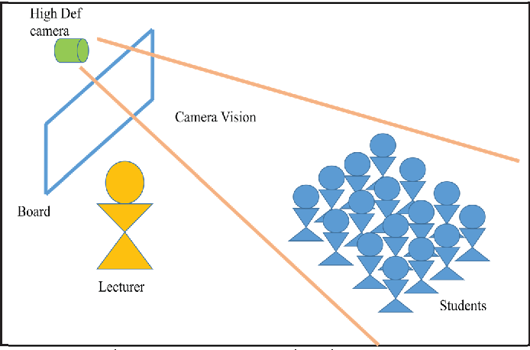

ll formal institutions of learning put a great premium on

class attendance and it is so vital that students who do not meet

the benchmark assigned to class attendance are not allowed to

sit for examination. An automated class attendance system that

uses iris biometric to take class attendance is the focus of this

paper. The attendance of students in a class is tracked and

automatically updated each time their iris gets scanned before

entering the class. The use of the iris as a biometric is quite

popular and favored by many res

ll formal institutions of learning put a great premium on

class attendance and it is so vital that students who do not meet

the benchmark assigned to class attendance are not allowed to

sit for examination. An automated class attendance system that

uses iris biometric to take class attendance is the focus of this

paper. The attendance of students in a class is tracked and

automatically updated each time their iris gets scanned before

entering the class. The use of the iris as a biometric is quite

popular and favored by many res

ll formal institutions of learning put a great premium on

class attendance and it is so vital that students who do not meet

the benchmark assigned to class attendance are not allowed to

sit for examination. An automated class attendance system that

uses iris biometric to take class attendance is the focus of this

paper. The attendance of students in a class is tracked and

automatically updated each time their iris gets scanned before

entering the class. The use of the iris as a biometric is quite

popular and favored by many res

All formal institutions of learning put a great premium on

class attendance and it is so vital that students who do not meet

the benchmark assigned to class attendance are not allowed to

sit for examination. An automated class attendance system that

uses iris biometric to take class attendance is the focus of this

paper. The attendance of students in a class is tracked and

automatically updated each time their iris gets scanned before

entering the class. The use of the iris as a biometric is quite

popular and favored by many researchers

**2. Automated Attendance Marking and Management System by Facial Recognition Using Histogram**

In proposed system an automated attendance marking and management system is proposed by using face detection and recognition algorithms. Identification of human faces by the unique characteristics or features of their face is known as Face recognition. Currently, Face recognition technology is the fastest growing technology. Instead of using the traditional methods, this proposed system aims to develop an automated system that records the student's attendance by using facial recognition technology for those who are present during lecture hours. The main objective of this work is to make the attendance marking and management system fully automatic, simple and easy. In this work the facial recognition of face is done by image processing techniques. The processed image is used to match with the existing stored record and then attendance is marked in the database correspondingly. Compared to existing system traditional attendance marking system, this system reduces the workload of people and also saves times.

This proposed system is been implemented with 4 modules such as Image Capturing, Segmentation of group photo and Face Detection, Face comparison and Recognition, Updating of Attendance in database.

**3.IRIS BASED BIOMETRIC SYSTEM**

### Biometric authentication is the process of verifying an individual based on behavioral and physiological characteristics. Iris recognition verification is one of the most reliable personal identification methods in biometrics. In the beginning, the idea of using iris patterns for personal identification was originally proposed in 1936 by ophthalmologist Frank Burch. By the 1980's the idea had appeared in James Bond films, but it still remained science fiction and conjecture. As biometric of human for identification purpose which cannot be stolen or lost. From the biometric system there exist different types of biometric such as thumb recognition, palm recognition, face recognition and iris recognition etc. Amongst which the iris is more preferred. The reason for the popularity of iris recognition verifying is the uniqueness, stability, permanency and easily taking. Iris recognition system is highly protected and stable that results in a single enrolment for the lifetime. The unique pattern on the surface of the iris is formed during the first year of life. Formation of the unique patterns of the iris is random and not related to any genetic factors. The only characteristic that is dependent on genetics is the pigmentation of the iris, which determines its color. Due to the epigenetic nature of iris patterns, the two eyes of an individual contain completely independent iris patterns, and identical twins possess uncorrelated iris patterns.

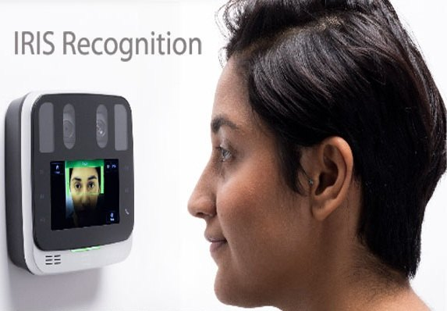

### 2.2 DRAWBACKS IN EXISTING SYSTEM

The major limitations of existing schemes are as follows: -

* All of these systems suffer from the limitation of human intervention to mark the attendance one by one at a time.
* These are time-consuming for a large number of students.
* Requires more manual work.
* High cost
* Proxy attendance possible

**3. PROPOSED SYSTEM**

## PROPOSED SOLUTION:

Face recognition attendance system has 4 steps:

1.finding all the faces

2. posing and projecting faces

3.Encoding faces

4.Finding person’s name from encoding

**1.Face recognition attendance system**

Face detection is a great feature for cameras. we’ll look at every single pixel in our image one at a time. For every single pixel, we want to look at the pixels that directly surrounding it. Our goal is to figure out how dark the current pixel is compared to the pixels directly surrounding it. Then we want to draw an arrow showing in which direction the image is getting darker. If you repeat that process for **every single pixel** in the image, you end up with every pixel being replaced by an arrow. These arrows are called gradients and they show the flow from light to dark across the entire image. This might seem like a random thing to do, but there’s a really good reason for replacing the pixels with gradients. If we analyze pixels directly, really dark images and really light images of the same person will have totally different pixel values. But by only considering the direction that brightness.

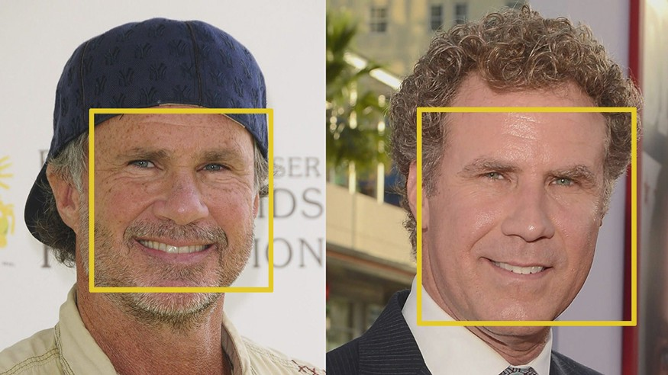

That makes the problem a lot easier to solve. But saving the gradient for every single pixel gives us way too much detail. It would be better if we could just see the basic flow of lightness/darkness at a higher level so we could see the basic pattern of the image. To do this, we’ll break up the image into small squares of 16x16 pixels each. In each square, we’ll count how many gradients point in each major direction. Then we’ll replace that square in the image with the arrow directions that were the strongest. The end result is we turn the original image into a very simple representation that captures the basic structure of a face in a simple way .To find faces in this HOG image, all we have to do is find the part of our image that looks the most similar to a known HOG pattern that was extracted from a bunch of other training faces. Using this technique, we can now easily find faces in any image.

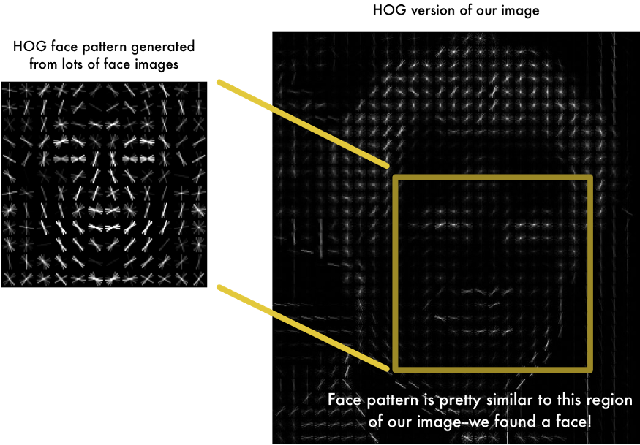

**2.Posing and Projecting Faces**

If the faces turned into different directions then we have to warp each picture so that the eyes and lips are always in the sample place in the image. This will make it a lot easier for us to compare faces in the next steps. To do this, we are going to use an algorithm called **face landmark estimation**. The basic idea is we will come up with 68 specific points (called landmarks) that exist on every face — the top of the chin, the outside edge of each eye, the inner edge of each eyebrow, etc. Then we will train a machine learning algorithm to be able to find these 68 specific points on face.

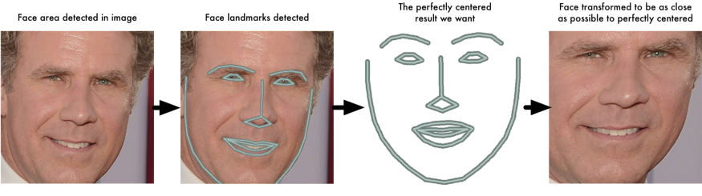

Now that we know were the eyes and mouth are. we’ll simply rotate, scale and shear the image so that the eyes and mouth are centered as best as possible. We won’t do any fancy 3d warps because that would introduce distortions into the image. We are only going to use basic image transformations like rotation and scale that preserve parallel lines.Now no matter how the face is turned, we are able to center the eyes and mouth are in roughly the same position in the image. This will make our next step a lot more accurate.

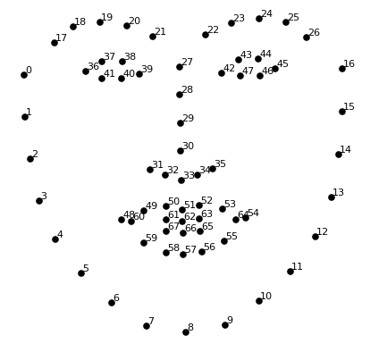

## 3.Encoding Faces

It turns out that the measurements that seem obvious to us humans (like eye colour) don’t really make sense to a computer looking at individual pixels in an image. Researchers have discovered that the most accurate approach is to let the computer figure out the measurements to collect itself. Deep learning does a better job than humans at figuring out which parts of a face are important to measure. The solution is to train a Deep Convolutional Neural Network .But instead of training the network to recognize pictures objects like we did last time, we are going to train it to generate 128 measurements for each face.

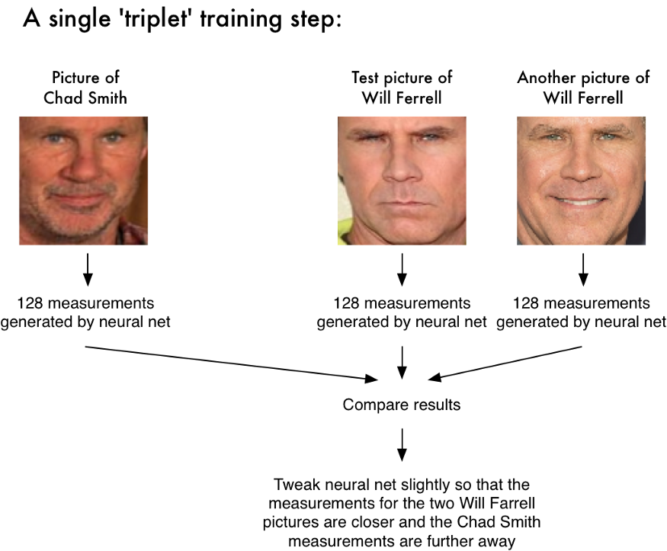

The training process works by looking at 3 face images at a time:

1. Load a training face image of a known person.
2. Load another picture of the same known person.
3. Load a picture of a totally different person.

Then the algorithm looks at the measurements it is currently generating for each of those three images. It then tweaks the neural network slightly so that it makes sure the measurements it generates for #1 and #2 are slightly closer while making sure the measurements for #2 and #3 are slightly further apart.

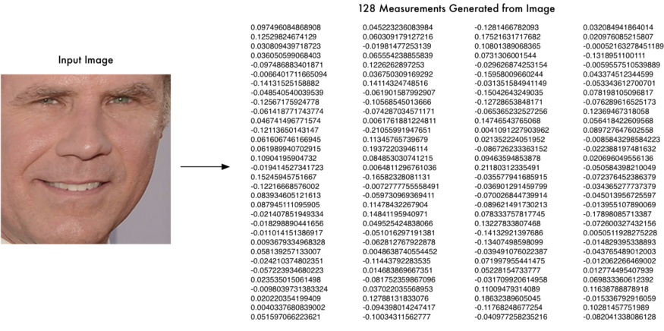

**4 Finding the person’s name from the encoding**

This last step is actually the easiest step in the whole process. All we have to do is find the person in our database of known people who has the closest measurements to our test image .All we need to do is train a classifier that can take in the measurements from a new test image and tells which known person is the closest match. Running this classifier takes milliseconds. The result of the classifier is the name of the person.

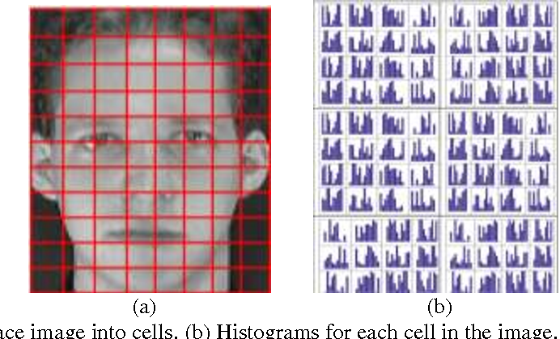

**ALGORITHM:**

**The Euclidean distance**

The Euclidean distance can be used to calculate the distance between any two points in twodimensional space, and also to measure the absolute distance between points in N-dimensional space.For face recognition, smaller values indicate more similar faces. The feature points representing facial features were calculated according to the Haar feature values, the image to be detected is processed by a function to obtain a 128-dimensional face feature vector, this constitutes the condition for face similarity calculation under Euclidean distance [7]. Suppose the face feature of the image to be detected 1 2 128 A xx x = ( , ,,, ) , training sample face features 1 2 128 B yy y = ( , ,,, ) ,the Euclidean distance calculation formula is as follows:



**d =√[(x2– x1)2 + (y2– y1)2]**



**FACE_RECOGNITION**

Face Recognition After the above process, the human face in the image to be detected is successfully intercepted. Then, using the face-encoding function, 128 feature vectors representing facial features can be extracted, The Euclidean distance is calculated by comparing the face features of the image to be detected with the trained face feature library. When the Euclidean distance value of the two sets of feature vectors is less than the threshold value (set as 0.43 in this paper), it indicates the success of face recognition, and the failure of face recognition on the contrary

**DESCRIPTION**

### In this proposed project an automated attendance marking and management system is proposed by making use of face detection and recognition algorithms. Instead of using the conventional methods, this proposed system aims to develop an automated system that records the student’s attendance by using facial recognition technology.

### ADVANTAGES OF PROPOSED SYSTEM

* It takes less amount of time to give attendance
* It easily identifies the students faces.
* It shows the log in time also.
* Low cost.
* Less manual work

**SYSYEM REQUIREMENTS**:

PYTHON DLIB

PYTHON NUMPY

PYTHON OPENCV

PYTHON CMAKE

**HARDWARE REQUIREMENTS:**

PROCESSOR : DUAL CORE 2 DUOS RAM : 4GB DD RAM HARD DISK : 250 GB

**MODULES IN SYSTEM:**

There are six modules in the project

* FACE DETECTION AND EXTRACTION
* RGB TO GRAY CONVERSION
* IMAGE ENHANCEMENT
* FEATURE EXTRACTION USING SHAPE FEATURES
* MATCHING

**How it works:**

### Face detection and extraction

Face detection is the process of detecting the region of face in an image. The face is detected by using the viola-jones method. The detected face is extracted automatically based on bounding box calculation. This is done to eliminate the background portion in the image and to extract only the face. This process is also known as ROI extraction.

### RGB to GRAY conversion

The input is the RGB (24bits/pixel) image. The RGB image is converted to grayscale image using RGB to gray conversion process. The output is the grayscale image (8 bits/pixel)

### Image enhancement

The images are noisy with rotational and translational variations. To remove these variations, it is subjected to pre processing steps. This process is called as Image enhancement. The image is enhanced by using Histogram Equalization (HE) for better visualization and to enhance the contrast of the image. Histogram Equalization (HE) is used to expand the pixel value distribution of an image so as to increase the contrast information. The histogram after the histogram equalization occupies all the range from 0 to 255 and the visualization effect is enhanced.

**Feature extraction using shape features**

In this stage, shape based features were extracted for the given input image. The shape based features are Area, Major axis length and minor axis length.

**Matching**

Based on the feature values of testing input image, we are going to classify that the given input image is matched or not. If a face is recognized, it is known, else it is unknown.The Voice playback will be played automatically, if the face is matched. The name of the recognized human will be played automatically using voice playback kit, if the face is matched. On the other hand, alarm/buzzer will ring for the unknown person. The extracted features of the input face image are matched with the feature already stored for the reference image. If it gets matched, finally the output will be resulted as face matched. If we are giving

any images which are not trained, then it will results as face not matched.

## 

## 

## 

## DESIGNING:

**CONTEXT DIAGRAM**

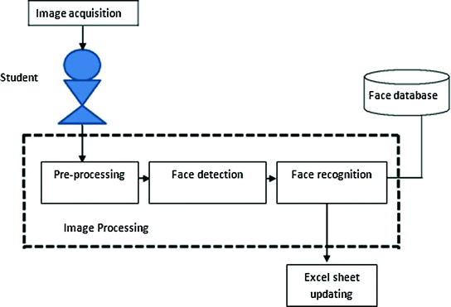

**ENTITY RELATIONSHIP DIAGRAMS**

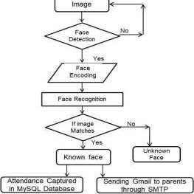

**5. RESULTS AND DISCUSSIONS**

In this module, the dataset for the student is created by using opencv python. One thousand image where collected from each and every students to create a dataset.The result of this proposed system is to mark the attendance for the students in the class by automatically using single group image.

* The marking of attendance is finally achieved in the excel sheet based on the presence or absence of the student which is detected in the above model using face recognition.The proposed automated attendance system using face recognition is a great model for marking the attendance of students in a classroom. This system also assists in overcoming the chances of proxies and fake attendance.

**FUTURE SCOPE**

This system also assists in overcoming the chances of proxies and fake attendance. In the modern world, a large number of systems using biometrics are available. However, the facial recognition turns out to be a viable option because of its high accuracy along with minimum human intervention. This system is aimed at providing a significant level of security.

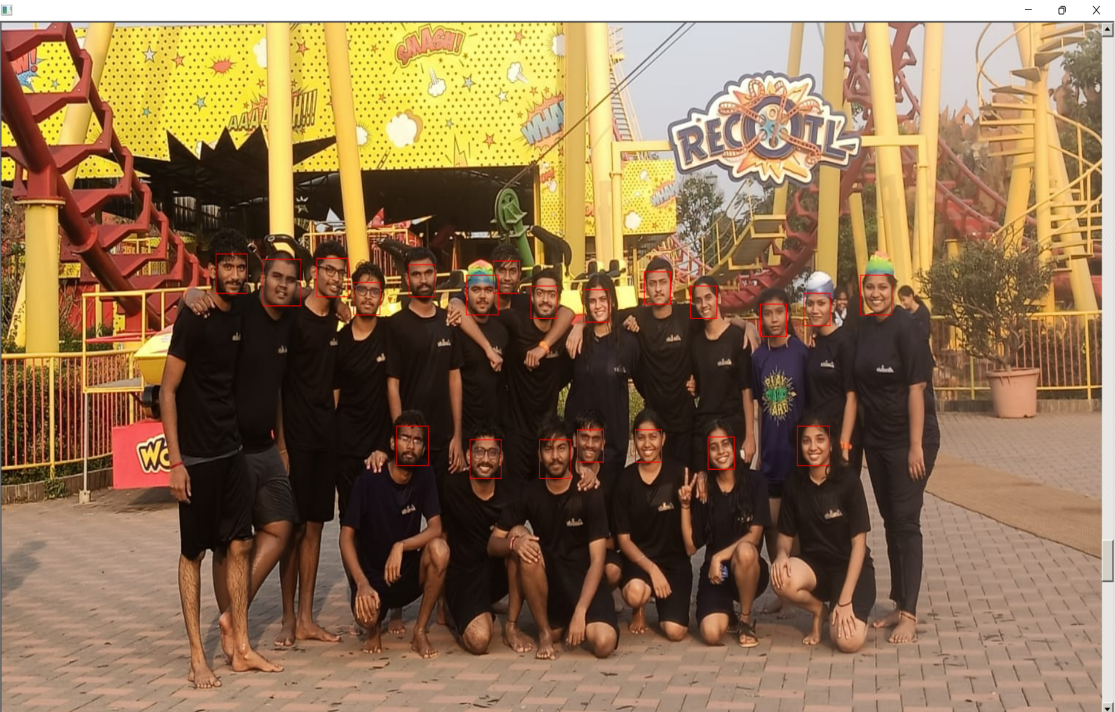

## 

**CONCLUSION:**

Automated Attendance System has been envisioned for reducing the drawbacks in the traditional (manual) system. This attendance system demonstrates the use of image processing techniques in classroom. The proposed automated attendance system using face recognition is a great model for marking the attendance of students in a classroom. This system can not only merely help in the attendance system, but also improve the goodwill of an institution

## REFERENCES:

* [1] P. Cocca, F. Marciano, and M. Alberti, ``Video surveillance systems to enhance occupational safety: A case study,'' Saf. Sci., 2016  
   [2] M. L. Garcia, Vulnerability Assessment of Physical Protection Systems. Oxford, U.K.: Heinemann, 2006.  
   [3] M. P. J. Ashby, ``The value of CCTV surveillance cameras as an investigative tool: An empirical analysis,'' Eur. J. Criminal Policy Res,2017  
   [4] B. C. Welsh, D. P. Farrington, and S. A. Taheri, ``Effectiveness and social costs of public area surveillance for crime prevention,'' 2015   
  [5] The Effectiveness of Public Space CCTV: A Review of Recent Published Evidence Regarding the Impact of CCTV on Crime, Police Community Saf. Directorate Scottish Government, Edinburgh, U.K., 2009.  
   [6] W. Hu, T. Tan, L. Wang, and S. Maybank, ``A survey on visual surveillance of object motion and behaviors,'' EEE Trans. Syst., Man, Cybern. C, Appl. Rev 2004  
   <https://medium.com/@ageitgey/machine-learning-is-fun-part-4-modern-face-recognition-with-deep-learning-c3cffc121d78>